**Praktikum 9**

**ASSOCIATION RULES MENGGUNAKAN WEKA**

Dataset untuk training :

|  |  |  |  |  |  |
| --- | --- | --- | --- | --- | --- |
| No | Graduate | Skill | Wellfare | Personality | Credit History |
| 1 | High School | Ok | Poor | Good | Succeed |
| 2 | Primary School | Not Ok | Very Poor | Good | Not Succeed |
| 3 | Primary School | Ok | Poor | Moderate | Not Succeed |
| 4 | High School | Ok | Poor | Good | Succeed |
| 5 | Primary School | Not Ok | Poor | Good | Not Succeed |
| 6 | Primary School | Ok | Very Poor | Moderate | Not Succeed |
| 7 | Primary School | Ok | Poor | Bad | Not Succeed |
| 8 | Primary School | Not Ok | Poor | Good | Not Succeed |
| 9 | Primary School | Not Ok | Poor | Good | Not Succeed |
| 10 | Primary School | Ok | Poor | Bad | Not Succeed |
| 11 | High School | Ok | Poor | Good | Succeed |

Langkah-langkah :

1. Install package weka excel melalui menu tools

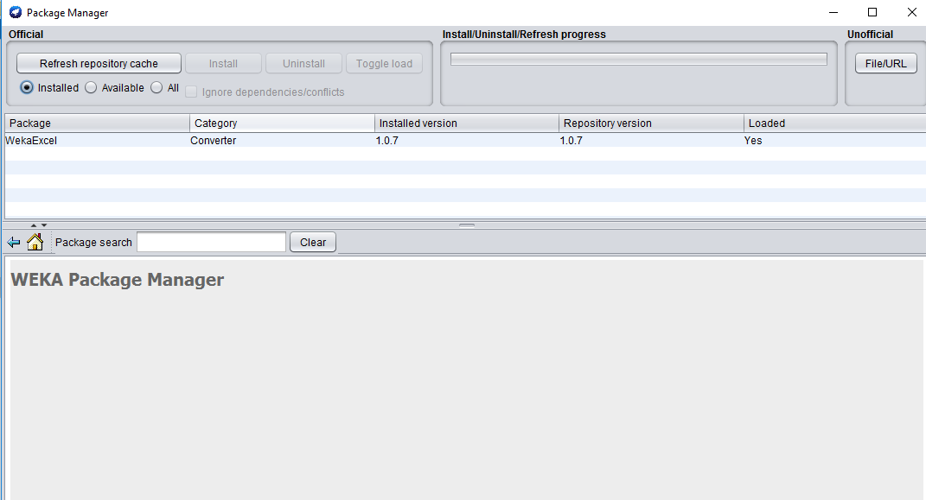

1. Klik preprocess untuk melakukan penginputan data dan pilih data yang akan di input

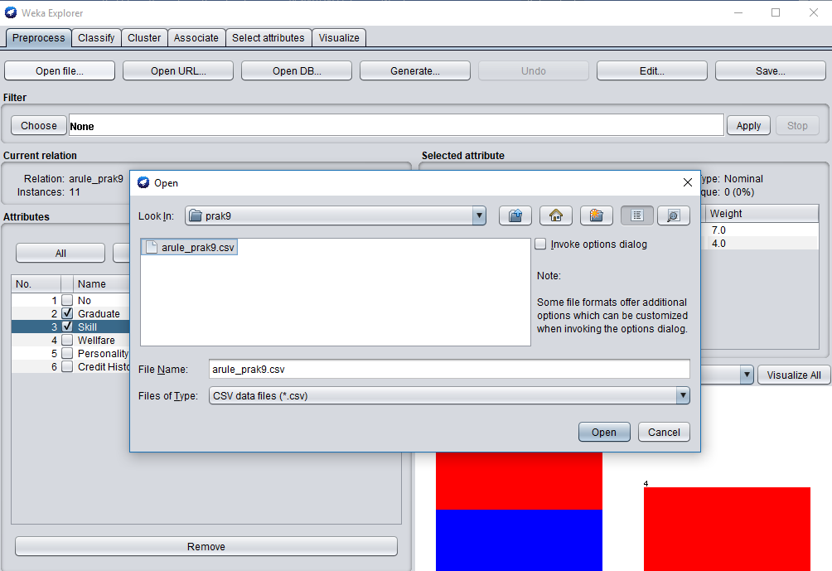

1. Pilih variabel dua variabel dulu yaitu Graduate dan Skill

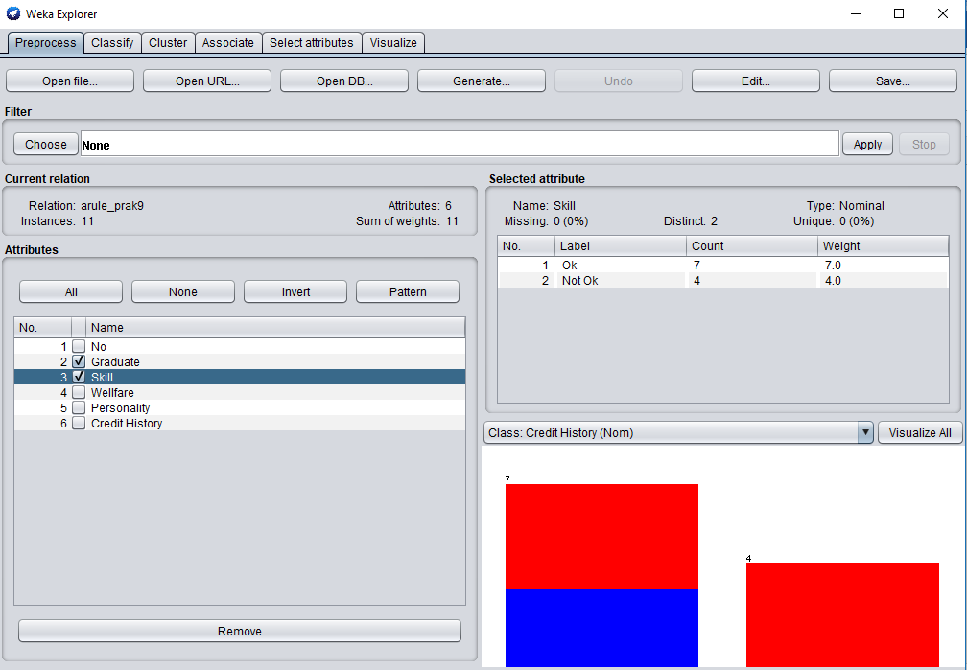

1. Klik Associate ==> Pilih Choose ==> pilih apriori ==>klik Start

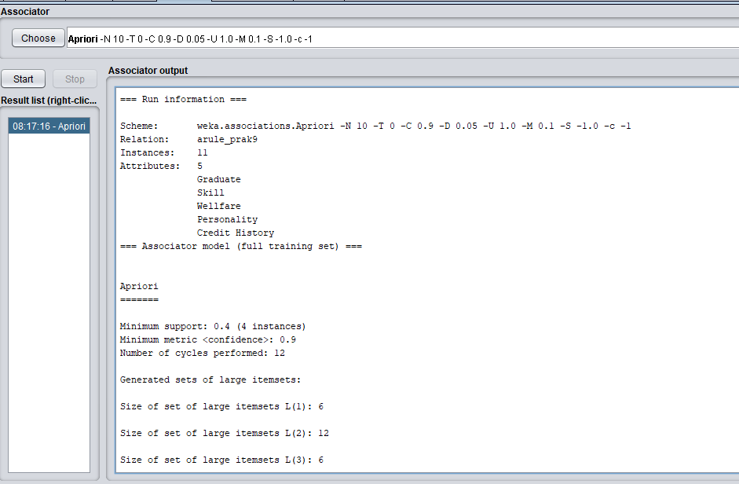

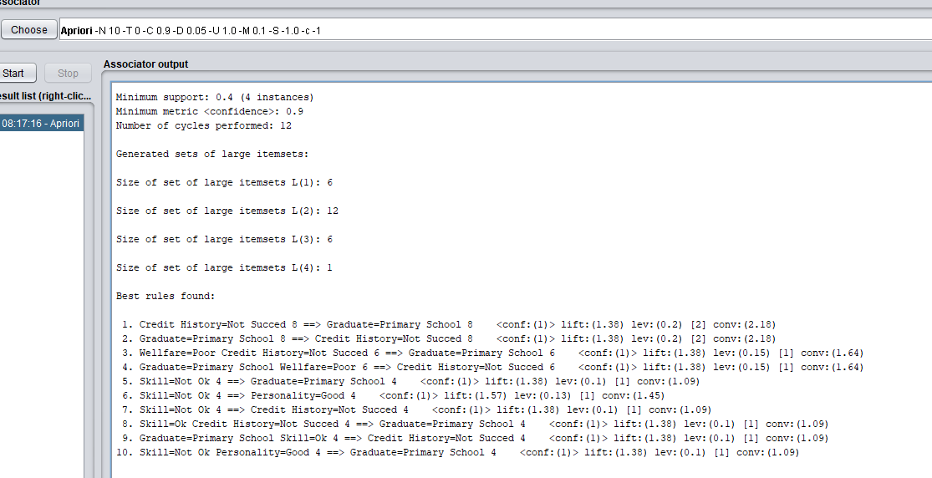

=== Run information ===

Scheme: weka.associations.Apriori -N 10 -T 0 -C 0.9 -D 0.05 -U 1.0 -M 0.1 -S -1.0 -c -1

Relation: arule_prak9

Instances: 11

Attributes: 5

Graduate

Skill

Wellfare

Personality

Credit History

=== Associator model (full training set) ===

Apriori

=======

Minimum support: 0.4 (4 instances)

Minimum metric <confidence>: 0.9

Number of cycles performed: 12

Generated sets of large itemsets:

Size of set of large itemsets L(1): 6

Size of set of large itemsets L(2): 12

Size of set of large itemsets L(3): 6

Size of set of large itemsets L(4): 1

Best rules found:

1. Credit History=Not Succed 8 ==> Graduate=Primary School 8 <conf:(1)> lift:(1.38) lev:(0.2) [2] conv:(2.18)

2. Graduate=Primary School 8 ==> Credit History=Not Succed 8 <conf:(1)> lift:(1.38) lev:(0.2) [2] conv:(2.18)

3. Wellfare=Poor Credit History=Not Succed 6 ==> Graduate=Primary School 6 <conf:(1)> lift:(1.38) lev:(0.15) [1] conv:(1.64)

4. Graduate=Primary School Wellfare=Poor 6 ==> Credit History=Not Succed 6 <conf:(1)> lift:(1.38) lev:(0.15) [1] conv:(1.64)

5. Skill=Not Ok 4 ==> Graduate=Primary School 4 <conf:(1)> lift:(1.38) lev:(0.1) [1] conv:(1.09)

6. Skill=Not Ok 4 ==> Personality=Good 4 <conf:(1)> lift:(1.57) lev:(0.13) [1] conv:(1.45)

7. Skill=Not Ok 4 ==> Credit History=Not Succed 4 <conf:(1)> lift:(1.38) lev:(0.1) [1] conv:(1.09)

8. Skill=Ok Credit History=Not Succed 4 ==> Graduate=Primary School 4 <conf:(1)> lift:(1.38) lev:(0.1) [1] conv:(1.09)

9. Graduate=Primary School Skill=Ok 4 ==> Credit History=Not Succed 4 <conf:(1)> lift:(1.38) lev:(0.1) [1] conv:(1.09)

10. Skill=Not Ok Personality=Good 4 ==> Graduate=Primary School 4 <conf:(1)> lift:(1.38) lev:(0.1) [1] conv:(1.09)

1. Lakukan perhitungan manual menggunakan excel untuk mendapatkan nilai support, confidence dan lift ratio sesuai output pada poin 4.
2. Pilih variabel yang sesuai pada WEKA untuk mendapatkan output seperti di bawah ini

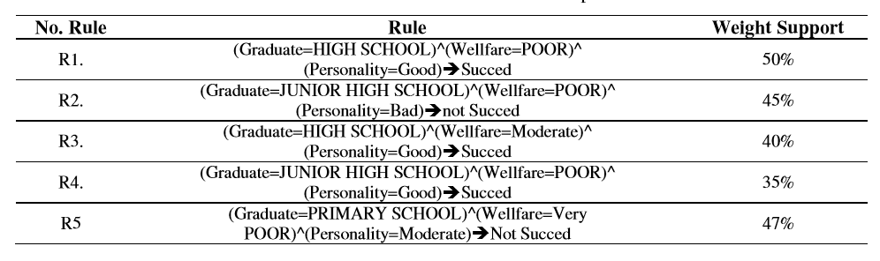

1. Dapatkan hasil prediksi ini menggunakan data testing seperti di bawah ini

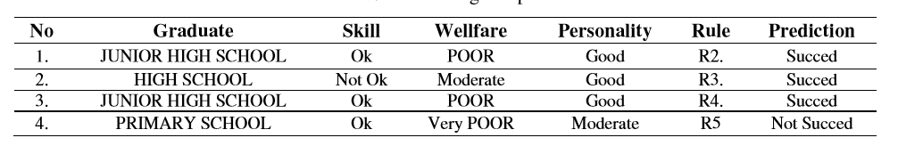

Sumber :

Aribowo, A.S., Cahyana, N.H. 2015. Feasibility study for banking loan using association rule mining classifier. International Journal of Advance in Intelligent Informatics. Vol 1. No 1. Pp. 41-47